**Exercise 6.1**

b) In order to plot the data in the same scale, we adjust the lawyer rate not per citizen, but per 100,000 citizens, using the data stored in the *pop* factor (see R code). We only have to multiply *lawyers* by 100, and divide by the corresponding population in order to have the same scale as the crime rate (per 100,000), because *pop* is measured in 1000.

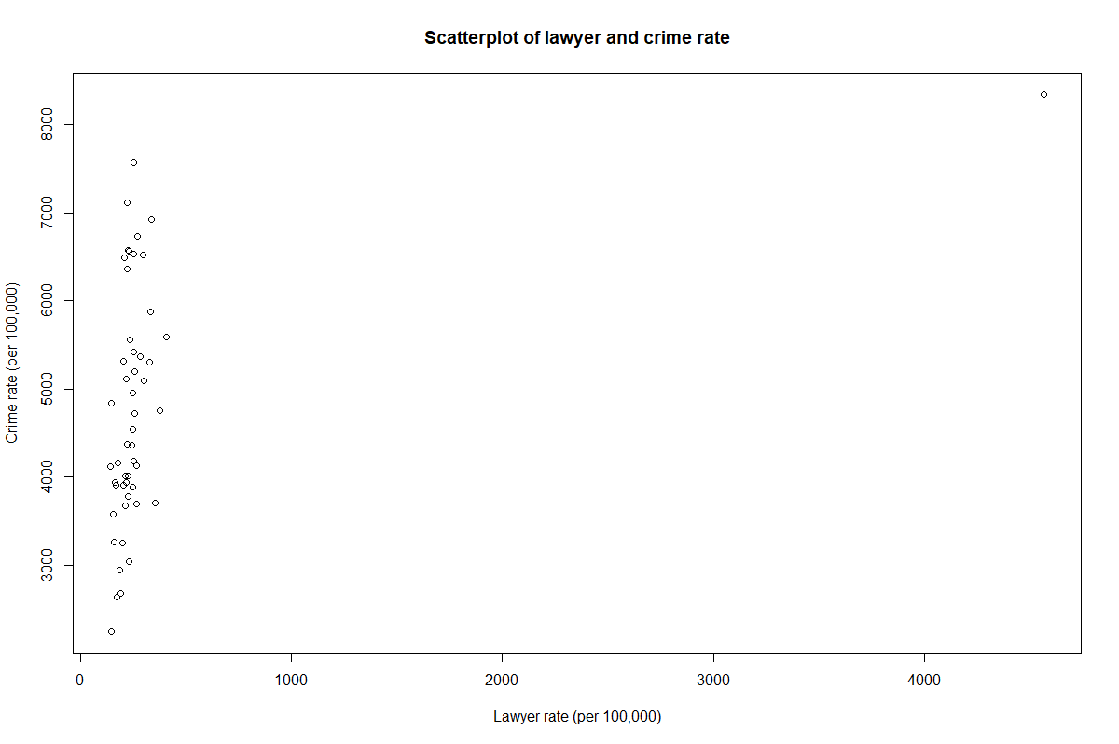

Unfortunately, it is hard to make up one trend, due to the high outlier (which is “DC”). We will leave this one out and zoom in on the trend of the rest:

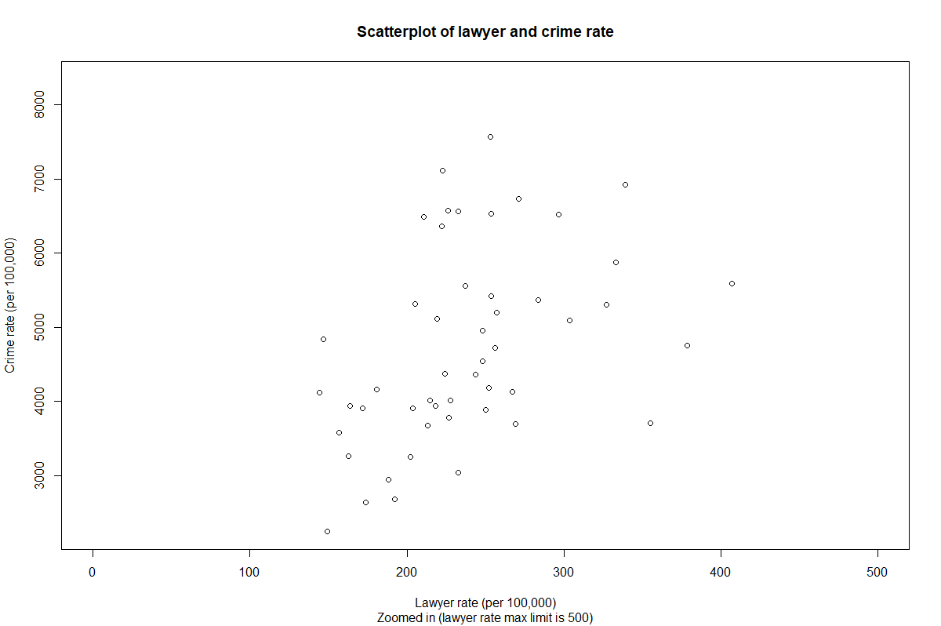

Based on the above scatterplot(s), we judge a positive correlation between crime and lawyer rate, as the above plot shows an overall positive trend. The left-out outlier also agrees with this positive correlation, as the crime rate and lawyer rate of that outlier were both very high (compared to the rest of the points in the previous scatterplot).

c)

We perform two-sided tests using the Kendall and Spearman rank correlation tests. Denote the sample as paired and i.i.d. where corresponds to the observed lawyer rate and to the observed crime rate. Note that . Furthermore, define:



For both tests, we use

**Spearman**

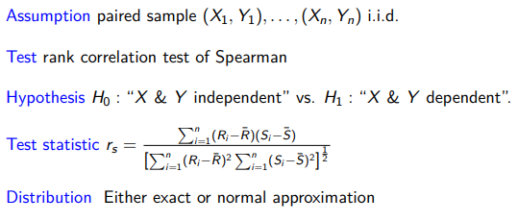

(As R does not give a warning message about, we think the exact distribution is used in the next calculation.) The test score for the sample is 0.528 (see R code). This gives a corresponding **p-value** of 0.000.

**Conclusion:** Since this p-value is lower than the significance level, we do reject the null hypothesis. Therefore we conclude that the lawyer and crime rate are dependent (with significant probability).

**Kendall**

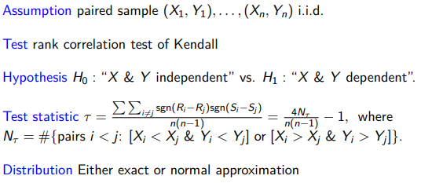

(As R does not give a warning message about, we think the exact distribution is used in the next calculation.) The test score for the sample is 0.369 (see R code). This gives a corresponding **p-value** of 0.000.

**Conclusion:** Since this p-value is lower than the significance level, we do reject the null hypothesis. Therefore we conclude that the lawyer and crime rate are dependent (with significant probability).

The **test statistic** is

The distribution of the test statistic under is